
TEMASEK JUNIOR COLLEGE

CHEMISTRY 9746/01
Paper 1 Multiple Choice

Tuesday 29th SEPTEMBER 2009 1 hour

Additional materials: Data Booklet
Multiple Choice Answer Sheet

READ THESE INSTRUCTIONS FIRST

Do not open this booklet until you are told to do so.

Write in soft pencil.
Do not use staples, paper clips, highlighters, glue or correction fluid.
Write your name, index number and CG on the Answer Sheet in the spaces provided.

There are forty questions on this paper. Answer all questions. For each question, there are four possible answers labelled A, B, C, and D.
Choose the one you consider correct and record your choice in soft pencil on the separate Answer Sheet.

Read the instructions on the Answer Sheet very carefully.

Each correct answer will score one mark. A mark will not be deducted for a wrong answer.
Any rough working should be done in this booklet.
You may use a calculator.

Section A
For each question there are four possible answers, A, B, C and D. Choose the one you consider to be correct.

1 | Given the following information:  ΔH_{c} (graphite) = -394 kJ mol⁻¹  ΔH_{f} (water) = -286 kJ mol⁻¹  ΔH_{f} (methanol) = -239 kJ mol⁻¹  Which one of the following is the correct ΔH_{c} (methanol) in kJ mol⁻¹?
 | A |  | -441
 | B |  | -727
 | C |  | -919
 | D |  | -1205
2 | In an experiment, 10 cm³ of an organic compound X in the gaseous state was sparked in excess oxygen. 20 cm³ of carbon dioxide and 5 cm³ of nitrogen were obtained among the products. All gas volumes were measured at the same temperature and pressure.  Which of the following compounds could be X?
 | A |  | C₂H₇N
 | B |  | C₂H₆N₂
 | C |  | C₆H₅NO₂
 | D |  | C₃H₅N
3 | Ozone reacts with nitric oxide according to the equation:  NO(g) + O₃(g) → NO₂(g) + O₂(g)  0.66g of NO(g) was mixed with 0.72g of O₃(g). What is the maximum volume of NO₂(g) produced at 0°C and 100 kPa?
 | A |  | 0.34 dm³
 | B |  | 0.37 dm³
 | C |  | 0.45 dm³
 | D |  | 0.50 dm³
4 | Why is ethanoic acid a stronger acid in liquid ammonia than in aqueous solution?
 | A |  | Ammonia is a stronger base than water
 | B |  | Ammonium ethanoate is completely ionised in aqueous solution
 | C |  | Ammonium ethanoate is strongly acidic in aqueous solution
 | D |  | Liquid ammonia is a more polar solvent than water.
5 | An acidified solution containing 0.10 mol dm⁻³ of zinc sulphate and 0.10 mol dm⁻³ of copper (II) sulphate is saturated with hydrogen sulphide at 15 ºC. The concentration of S²⁻ (aq) in the solution is then 10⁻³⁵ mol dm⁻³.  The solubility product of zinc sulphide at 15ºC is 10⁻²⁴ mol²dm⁻⁶ and that of copper (II) sulphide is 10⁻⁴⁰ mol²dm⁻⁶.  Which statement describes what happens in the solution?
 | A |  | No precipitate is formed.
 | B |  | Copper (II) sulphide only is precipitated.
 | C |  | Copper (II) sulphide is precipitated followed by zinc sulphide.
 | D |  | Zinc sulphide is precipitated followed by copper (II) sulphide.
6 | AlCl₃ reacts with LiAlH₄ and (CH₃)₃NAlH₃. Which statements about (CH₃)₃NAlH₃ is correct?
 | A |  | It contains hydrogen bonding
 | B |  | It is dimeric
 | C |  | The Al atom is electron deficient
 | D |  | The bonds around the Al atom are tetrahedrally arranged
7 | When 0.20 mol of hydrogen gas and 0.15 mol of iodine gas are heated at 723 K until equilibrium is established, the equilibrium mixture is found to contain 0.26 mol of hydrogen iodide.  The equation for the reaction is as follows.  H₂(g) + I₂(g) 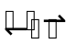 2HI(g)  What is the correct expression for the equilibrium constant K_{c}?
 | A |  | 2 x 0.26 __  0.20 x 0.15
 | B |  | (2 x 0.26)²  0.20 x 0.15
 | C |  | (0.26)²___  0.07 x 0.02
 | D |  | (0.26)²___  0.13 x 0.13
8 | Ions of the two most common isotopes of the transition metal nickel are shown below:  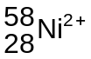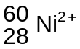  Which one of the following statements is true?
 | A |  | The electron arrangement of both these Ni²⁺ ions is 1s²2s²2p⁶3s²3p⁶3d⁶4s².
 | B |  | The ion will have more protons in its nucleus than the ion.
 | C |  | In the same strength magnetic field, the 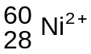ion will be deflected more than the ion.
 | D |  | Both of these Ni²⁺ ions have the same number of electrons but a different number of neutrons.
9 | Which of the following conversions involves an oxidation of vanadium?
 | A |  | VF₅ → V₂O₅
 | B |  | VO²⁺ → V²⁺
 | C |  | VO²⁺ → V³⁺
 | D |  | VO²⁺ → VO₂⁺
10 | Substances X, Y and Z react according to the following equation:  X(aq) + 2Y(aq) + Z(aq) → 2W(aq) + U(aq)  To find the rate equation for the above reaction, two sets of separate experiments were performed, in which the initial concentrations of each of the reactants X, Y and Z were varied in turn, the other two being kept constant. The results are shown below.  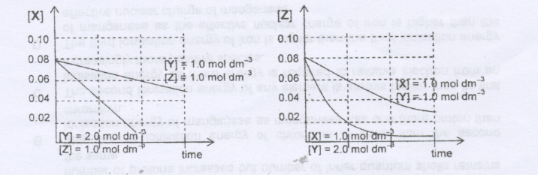  If k is the rate constant, the rate equation is most likely to be:
 | A | rate = k[X][Y][Z] |  |  |  |  | B |  | rate = k[X][Y]²[Z]
 | C | rate = k[Y]²[Z] |  |  |  |  | D |  | rate = k[Y][Z]
11 | A Fe³⁺/Fe²⁺ half-cell was connected to a Ni²⁺/Ni half-cell as shown in the diagram below under standard conditions.  Ni  1.0 mol dm⁻³ Ni²⁺(aq)  1.0 mol dm⁻³ , Fe³⁺(aq), Fe²⁺(aq)  Pt  Salt bridge  V  Which of the following statements is incorrect?
 | A |  | The solution in the Fe³⁺/Fe²⁺ half cell turns green.
 | B |  | The standard cell potential is +1.02 V.
 | C |  | The electron flows from the Ni²⁺/Ni half cell to the Fe³⁺/Fe²⁺ half cell.
 | D |  | The cathode decreases in size.
12 | Which factors determine the number of atoms of copper deposited on the cathode of an electrolytic cell?
 |  |  | [Ag⁺aq] |  | current |  |  |  |  |  |  | Time
 | A |  | √ |  | x |  |  |  |  |  |  | x
 | B |  | x |  | √ |  |  |  |  |  |  | √
 | C |  | √ |  | √ |  |  |  |  |  |  | x
 | D |  | √ |  | √ |  |  |  |  |  |  | √
13 | When a sample of 0.01 mol of hydrocarbon was completely burnt in oxygen, 2.20 g of carbon dioxide gas was formed at room temperature and pressure. The same amount of hydrocarbon is also found to react with 50 cm³ of 0.4 mol dm⁻³ of aqueous bromine.  Which of the following could this hydrocarbon be?
 | A |  | CH₃CHCHCH₃
 | B |  | CH₂CHCH₂CH₃
 | C |  | CH₂CHC(CH₃)CH₂
 | D |  | CH(CH₃)CHCH₂CH₃
14 | Geraniol has a rose-like odour and is commonly used in perfumes.  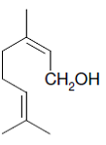  geraniol  Which of the following is not formed when geraniol reacts with hot acidified potassium managanate(VII)?
 | A |  | 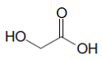 |  |  |  | B |  | (CO₂H)₂
 | C |  | 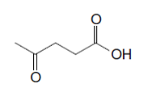 |  |  |  | D |  | 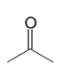
15 | Compound P can be converted to compound Q in a sequence of steps.  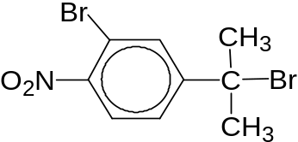  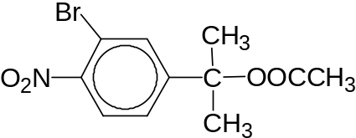  P  Q  Which of the following statements is correct?
 | A |  | The sequential conversion of P to Q involves a nucleophilic substitution reaction, acidic hydrolysis and esterification.
 | B |  | Compound P must be converted into an alkene first in the first step of conversion to compound Q.
 | C |  | When hot aqueous alkaline iodine is added to separate samples of P and Q, only compound P forms a yellow precipitate.
 | D |  | When hot aqueous sodium hydroxide is added separately to compounds P and Q, only compound P gives a pale yellow precipitate when added to silver nitrate solution.
16 | Partial hydrolysis of insulin, the hormone essential for carbohydrate metabolism, gives the following tripeptide.  (CH₃)₂CHCH(NH₂)CONHCHCONHCH(CH₃)CO₂H  CH₂CH₂CO₂H  |  Which compound could be obtained by further hydrolysis of this tripeptide?
 | A |  | H₂NCHCONHCH(CH₃)CO₂H  CH₂CH₂CO₂H  |
 | B |  | H₂OCNHCHCO₂H  CH₂CH₂CO₂H  |
 | C |  | CH₃CH(CO₂H)₂
 | D |  | (CH₃)₂CHCH(NH₂)CONH₂
17 | Which pair of reactions could form the same common intermediate?  I CH₃CH(OH)CH₃ → intermediate → (CH₃)₂C(OH)CN  II CH₃CHCH₂ → intermediate → CH₃CH(OH)CH₃  III CH₃CH₂CH₃ → intermediate → (CH₃)₂CHCN  IV CH₃CO₂CH₂CH₂CH₃ → intermediate → CH₃CH₂CH₂Br
 | A |  | I and II
 | B |  | I and III
 | C |  | II and III
 | D |  | III and IV
18 | What is the total number of possible stereoisomers that can be formed when the following compound reacts with excess concentrated H₂SO₄?  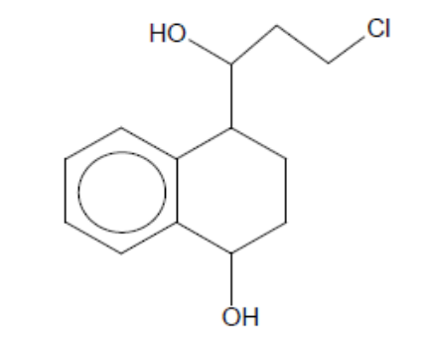
 | A |  | 2
 | B |  | 4
 | C |  | 6
 | D |  | 8
19 | The following compound, Vitamin C is soluble in water.  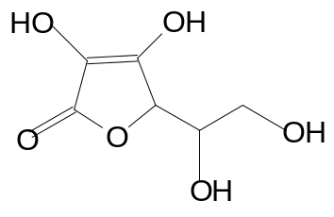  Which one of the following statements is correct?
 | A |  | The molecule is planar.
 | B |  | It can exist as cis-trans isomers.
 | C |  | It can react with hot sodium hydroxide.
 | D |  | It can react with 2,4-dinitrophenylhydrazine to form a bright orange precipitate.
20 | The reduction of a nitrile P produced a compound of the formula CH₃CH₂NH₂. The same nitrile P was then hydrolysed in acidic medium. What would be formed if the products from the two reactions are mixed together?
 | A |  | CH₃CONHCH₂CH₃
 | B |  | CH₃CH₂CONHCH₂CH₃
 | C |  | (CH₃CO₂⁻)(CH₃CH₂NH₃⁺)
 | D |  | (CH₃CH₂CO₂⁻)(CH₃CH₂NH₃⁺)
21 | Acetaminophene is a drug used in headache remedies. It has the structure:  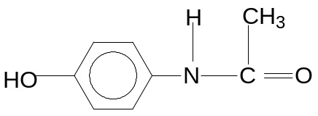  Which of the following equations gives the best method for its synthesis?
 | A |  | 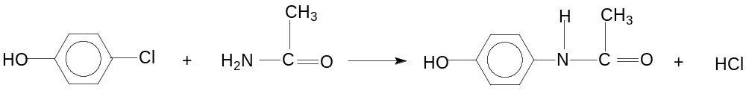
 | B |  | 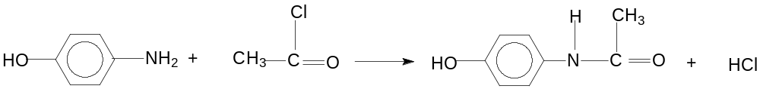
 | C |  | 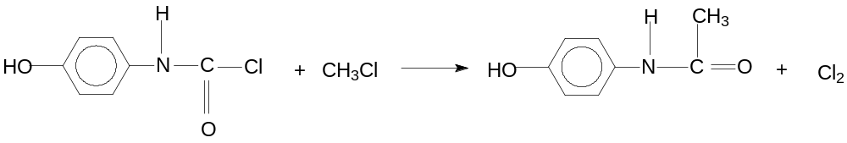
 | D |  | 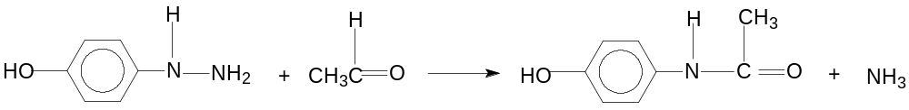
22 | Which sequence shows the nitrogen compounds of decreasing pK_{b}?
 | A |  | 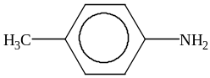 | 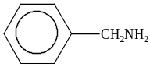 |  |  |  |  |  | 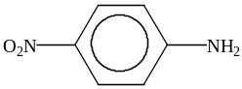 |  |  |  | 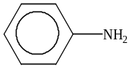
 | B |  | 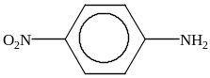 |  |  |  |  |  |  | 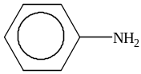 |  |  |  | 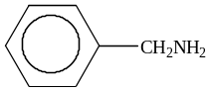
 | C |  |  | 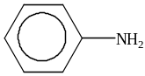 |  |  |  |  |  | 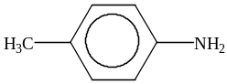
 | D |  | 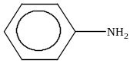 |  |  |  |  |  |  | 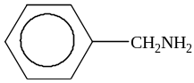
23 | Which of the following statements is true for strontium or its compounds?
 | A |  | Strontium does not burn in air.
 | B |  | Strontium does not react with steam.
 | C |  | Strontium hydroxide is dehydrated to the oxide on being heated.
 | D |  | Strontium carbonate decomposes at a lower temperature than calcium carbonate.
24 | Which of the following oxides is unlikely to dissolve in aqueous sodium hydroxide?
 | A |  | Al₂O₃
 | B |  | MgO
 | C |  | P₄O₁₀
 | D |  | SiO₂
25 | Astatine is the element below iodine in Group VII of the Periodic Table. It is radioactive with a short half-life, hence its chemistry is not easily investigated.  Which of the following would not be a correct prediction of astatine or its compounds?
 | A |  | Astatine would be soluble in ether.
 | B |  | Astatine is a solid at room temperature.
 | C |  | Silver astatide is soluble in aqueous ammonia.
 | D |  | Aqueous hydrogen astatide has a lower pH than aqueous hydrogen iodide of the same concentration.
26 | P, Q and R are chlorides of some elements in the Periodic Table.
 | Observations
 | Reaction of solid with water | Reaction of aqueous solution with aq NaOH
P | White fumes are liberated | White ppt soluble in excess
Q | No fumes evolved | No ppt
R | White fumes are liberated | No ppt
 | Which of the following is the correct combination of P, Q and R?
 |  |  | P |  |  | Q |  |  |  |  |  |  | R
 | A |  | AlCl₃ |  |  | NaCl |  |  |  |  |  |  | PCl₅
 | B |  | ZnCl₂ |  |  | BaCl₂ |  |  |  |  |  |  | SiCl₄
 | C |  | PbCl₂ |  |  | S₂Cl₂ |  |  |  |  |  |  | SiCl₄
 | D |  | AlCl₃ |  |  | MgCl₂ |  |  |  |  |  |  | PCl₅
27 | The graph below shows the variation in the molar enthalpy change of vapourization for eight consecutive elements in the Periodic Table all with atomic number, Z< 20.  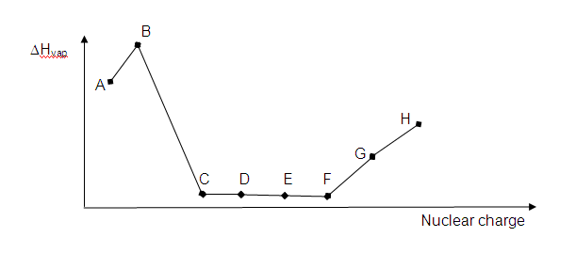  Which of the following statements is correct?
 | A |  | Element A is in the same group as beryllium in the Periodic Table.
 | B |  | Element B forms an oxide which is acidic in aqueous solution.
 | C |  | Element F exists as diatomic molecules.
 | D |  | Element G will form amphoteric oxides.
28 | Chlorine is formed when
 | A |  | iodine is heated strongly with sodium chloride
 | B |  | dilute hydrochloric acid is heated with manganese(IV) oxide
 | C |  | chromium(III) chloride is heated with concentrated sulphuric acid
 | D |  | sodium chloride is heated with concentrated sulphuric acid and manganese(IV) oxide
29 | Which of the following statements is correct?
 | A |  | The third ionisation energy of calcium is higher than scandium as the Ca²⁺ ion has a larger ionic radius compared to the Sc²⁺ ion.
 | B |  | The second ionisation energy of chromium is lower than the second ionisation energy of manganese as manganese has one more proton than chromium.
 | C |  | The second ionisation energy of any element is always higher than its first ionisation energy as more energy is required to remove electron from an increasingly more positive species.
 | D |  | The third ionisation energy of iron is higher than the third ionisation energy of manganese as the effective nuclear charge of iron is higher than the effective nuclear charge of manganese.
30 | Which of the following graphs shows the correct trend in the physical property of the period III elements?
 | A |  | 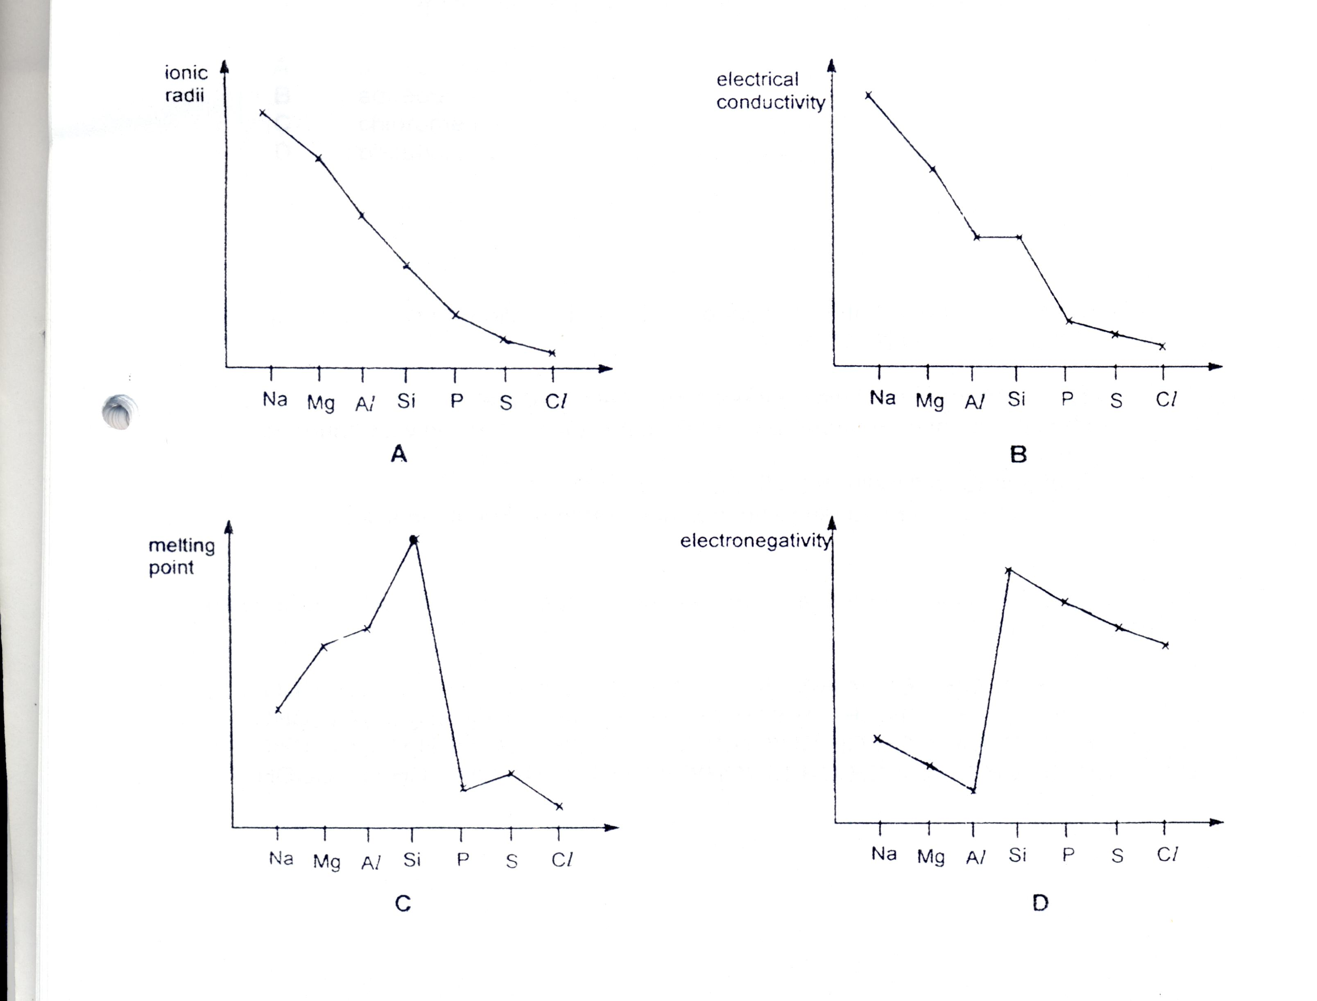 |  |  |  |  | B
 | C |  |  |  |  |  |  | D
Section B
For each of the questions in this section, one or more of the three numbered statements
1 to 3 may be correct.

Decide whether each of the statements is or is not correct (you may find it helpful to put a tick against the statements which you consider to be correct).

The responses A to D should be selected on the basis of

A | B | C | D
1, 2 and 3  are correct | 1 and 2  only are correct | 2 and 3  only are correct | 1 only is correct
No other combination of statements is used as a correct response.

31 | The reaction between KI(aq) with excess Na₂S₂O₈(aq) was studied and the following graph was obtained.  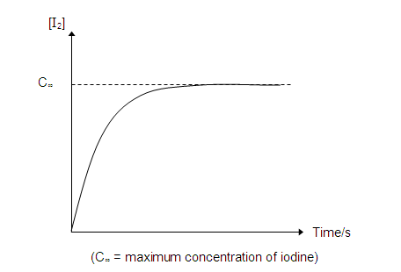  What information may be obtained from the graph above?
 | 1 |  | the rate of reaction at any given instant
 | 2 |  | order of reaction with respect to I⁻
 | 3 |  | order of reaction with respect to S₂O₈^{2─}
32 | In the ideal gas Law equation:  PV = nRT  each symbol has its usual meaning. Which of the following statements are correct?
 | 1 |  | Real gas deviates most from ideal gas behaviour at high pressure and low temperature.
 | 2 |  | The density of an ideal gas at constant pressure is inversely proportional to the absolute temperature.
 | 3 |  | The volume of the gas of an ideal gas is doubled when its temperature is raised from 25°C to 50°C at constant pressure.
33 | The use of chlorine as a disinfectant in swimming pools is now widely banned and the weak acid trichloroisocyanuric acid is used instead.  trichloroisocyanuric acid + OH⁻ ClO⁻ + cyanuric acid  The ClO⁻ ion is the effective disinfectant.  Why is it necessary to keep the pH of the water at 7.5?
 | 1 |  | The concentration of H⁺ is too low for the following reaction to occur;  2H⁺(aq) + ClO⁻(aq) + Cl⁻(aq) H₂O(l) + Cl₂(g)
 | 2 |  | The concentration of the ClO⁻ ion depends on the pH
 | 3 |  | At a pH of 7.5, the concentration of the ClO⁻ ion is at a maximum
34 | When 0.1 moles of Cl-CH₂-CH₂-CO₂H is added to 1 dm³ of water, the pH of the resulting solution is 3.86. Which of the following compounds will form a solution of pH lower than 3.86 when 0.1 moles of it is dissolved in 1 dm³ of water?
 | 1 |  | CH₃-CHCl-CO₂H
 | 2 |  | F-CH₂-CH₂-CO₂H
 | 3 |  | CH₃-CH₂-COCl
35 | Which of the following compounds produce effervescence of carbon dioxide gas when they are reacted with hot acidified potassium manganate(VII)?
 | 1 |  | CH₃-CH=CH₂
 | 2 |  | HO₂C-CO₂H
 | 3 |  | HO-CH₂-CHO
36 | Which of the following set of reagents and conditions can be used to form the organic product CH₃-CH(OH)-CH₂-CO₂H from CH₃-CO-CH₂-CO₂H?
 | 1 |  | LiAlH₄, dry ether as solvent, room temperature
 | 2 |  | H₂, nickel catalyst at 140 ºC
 | 3 |  | Zinc in dilute hydrochloric acid
37 | Which of the following chemical tests can be used to differentiate between the following compounds?  CHO  HO  C  H₂N  CH₃  O
 | 1 |  | Iodine in aqueous sodium hydroxide, reflux
 | 2 |  | Fehling’s solution, warm
 | 3 |  | Bromine water, room temperature

38 | Which of the following reactions will most likely form a racemic product mixture?
 | 1 | CH₃CHO with HCN in trace amounts of alkali, 10 - 20 ºC
 | 2 | CH₃CH₂CH₂  CH₃CH₂  C  CH₃  Cl  with aqueous sodium hydroxide, reflux
 | 3 | CH₃CH₂  C  CH₃  CH₃  C  H  with Br₂ dissolved in CCl₄
39 | For the sequence hydrogen chloride, hydrogen bromide and hydrogen iodide, there is an increase in
 | 1 | thermal stability
 | 2 | bond length
 | 3 | ease of oxidation
40 | The following data refer to copper as a typical transition element and to calcium as an s-block element.  For which property are the data under the correct element?
 |  | Property | copper | calcium
 | 1 | metallic radius/nm | 0.197 | 0.117
 | 2 | electrical conductivity/ relative units | 85 | 9.6
 | 3 | melting point/⁰C | 1083 | 810

